Developing a Novel Fatigue Index:

Metrics and Regression Modeling for sEMG-Based Muscle Fatigue Analysis

# Introduction

Muscle fatigue is a critical physiological phenomenon, impacting performance in sports, rehabilitation, and daily activities. Surface electromyography (sEMG) signals are widely used to monitor muscle activity and have shown potential in evaluating fatigue. However, existing methods often rely on indirect or predefined fatigue indicators, limiting their ability to provide a comprehensive measure of fatigue progression.

In this study, we present a two-fold approach to advance the understanding and measurement of muscle fatigue:

1. **Metric Evaluation**: We collected sEMG data from multiple participants performing sustained muscle contractions under continuous fatigue. From this data, we identified and validated custom metrics that reliably correlate with fatigue progression.
2. **Regression Modeling**: Recognizing the absence of a direct measure of fatigue, we explored regression techniques to develop a new fatigue index. By testing different hypothetical fatigue trends over time, we trained models to approximate these trends using the identified metrics, achieving a robust representation of fatigue progression.

This work not only identifies key fatigue-related metrics but also introduces a novel method to quantify fatigue trends, paving the way for more precise applications in monitoring and managing muscle fatigue.

Table of Contents

Introduction 1

1. Measurement and Metric Evaluation 2

2. Regression Modeling for Fatigue Index Creation 9

# 1. Measurement and Metric Evaluation

* **Objective**:

To measure sEMG signals from multiple participants while their muscle was under continuous fatigue and identify custom metrics that correlate strongly with fatigue levels.

* **Experimental Setup**:

The measurement process consists 3 phases, at first a rest_phase for some seconds, then the activation_phase (the participant extends his leg to maintain a stable position for the isometric contraction) and ultimately the active_phase where the leg remains extended for almost a minute.

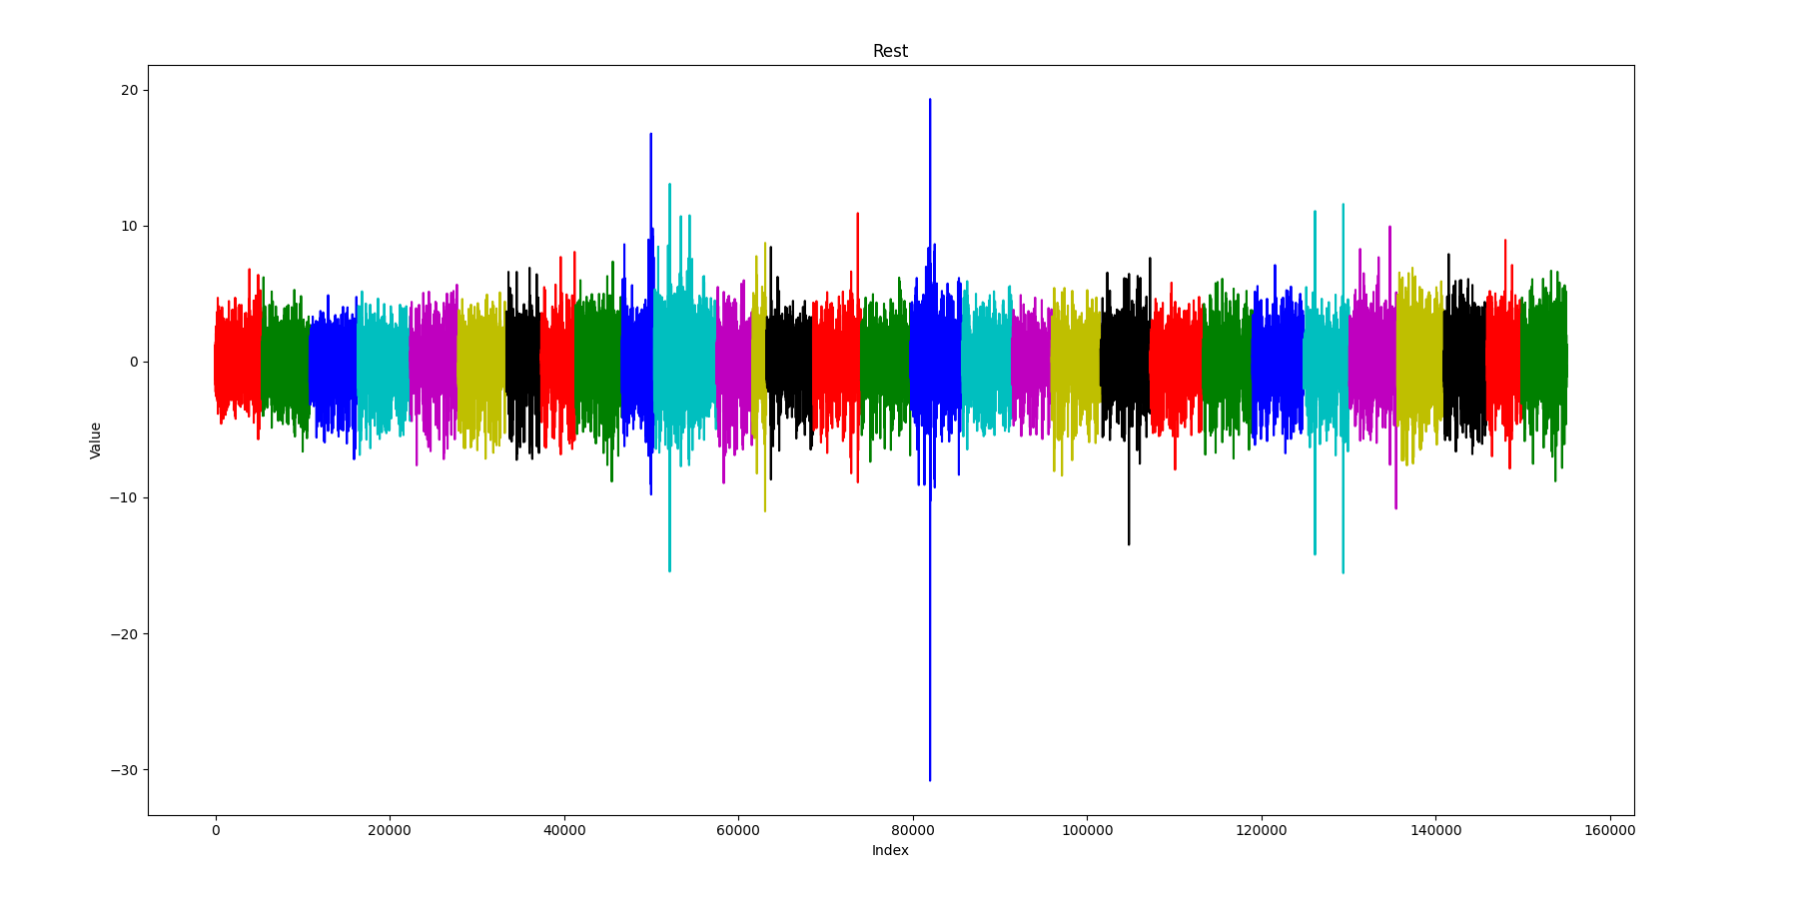

Figure 1:Rest phase side by side for multiple participants

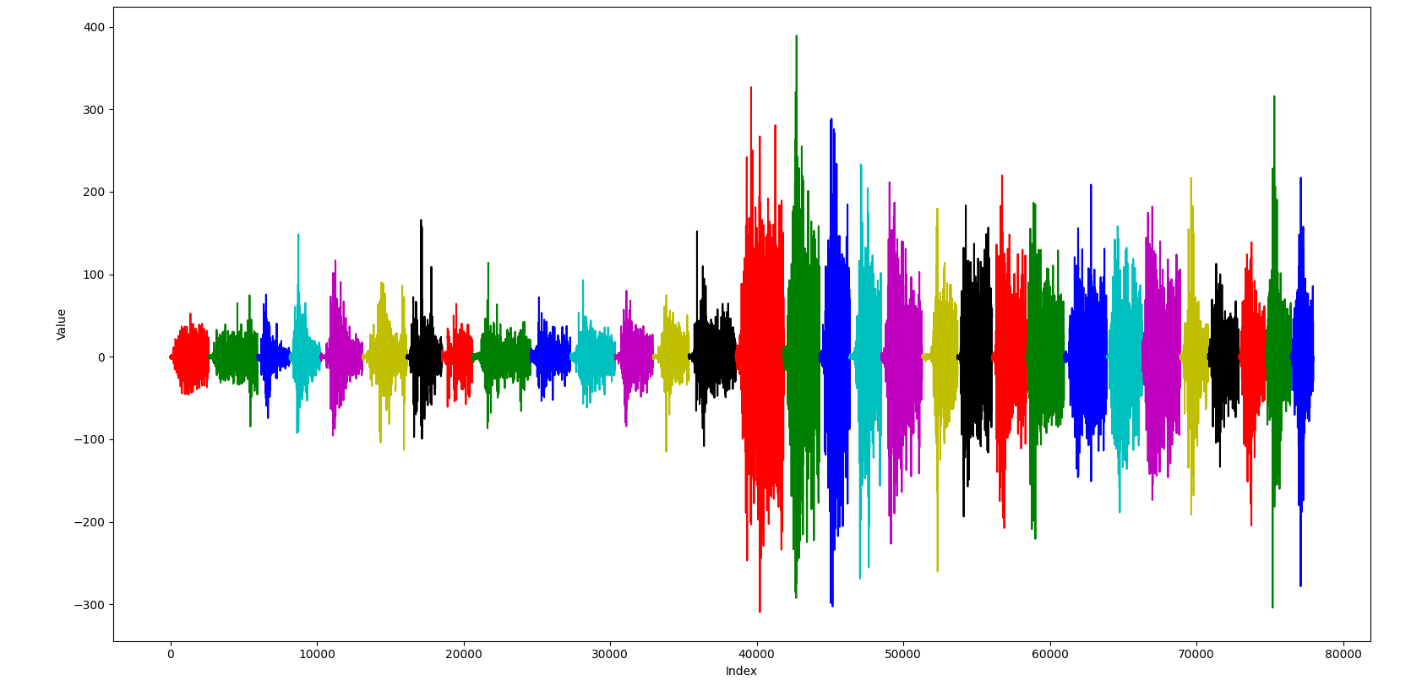

Figure 2:Activation phase side by side for multiple participants

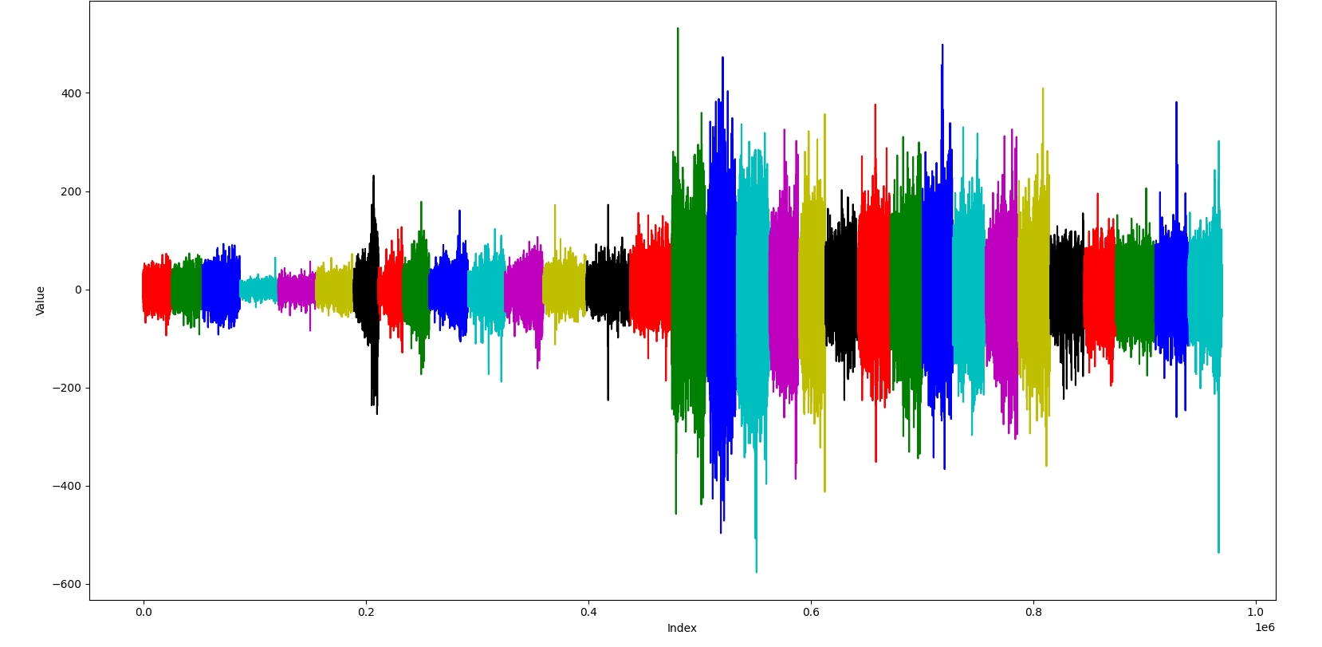

Figure 3:Active phase side by side for multiple participants

* **Data Collection**:

The sEMG signal is processed using a 4th-order band-pass Butterworth IIR filter implemented as cascaded second-order sections (biquads). This filter isolates the frequency range of 25 Hz to 380 Hz, which corresponds to typical sEMG activity, while suppressing noise outside this range.

The 50Hz is eliminated because in the experiment, the custom sEMG device was being powered with a powerbank of 5V output.

* **Metric Analysis**:

During the implementation of the thesis, the basic metrics used to extract conclusions where RMS, Integrated EMG, Mean Frequency and Median Power Frequency. While these metrics are very promising, when used alone they cannot provide very meaningful results regarding the progression of fatigue but only for the existence of the fatigue. Meanwhile, when using a fusion of metrics things can become more interesting.

From the study of additional bibliography, these parts are interesting:

1. The MNF/ARV ratio (<https://ieeexplore.ieee.org/document/7591924>, <https://ieeexplore.ieee.org/document/982283> ) is calculated and regarded as an index of muscle fatigue, where the ratio gradually decreases as fatigue progresses. Fatigue exists once the ratio reaches a specific baseline, which is defined as the inverse value of the MNF/ARV. As reported by the authors, the initial values of the MNF and ARV (Absolute Rectified Value) are taken as the reference values for the baseline to eliminate individual differences. The correlation coefficient between MNF and ARV is taken as an index of fatigue. The conversion of the correlation coefficient from positive to negative is regarded as a sign of muscle fatigue. Below, there are the plots of the MNF/ARV ratio which as mentioned in the bibliography it gradually decreases as fatigue progresses.

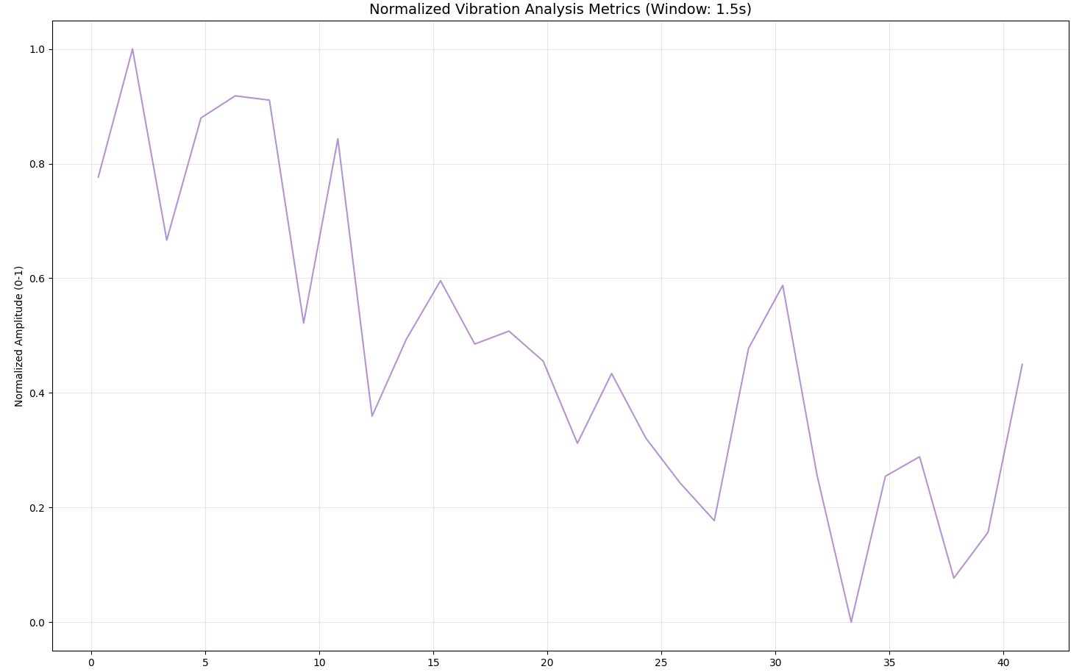

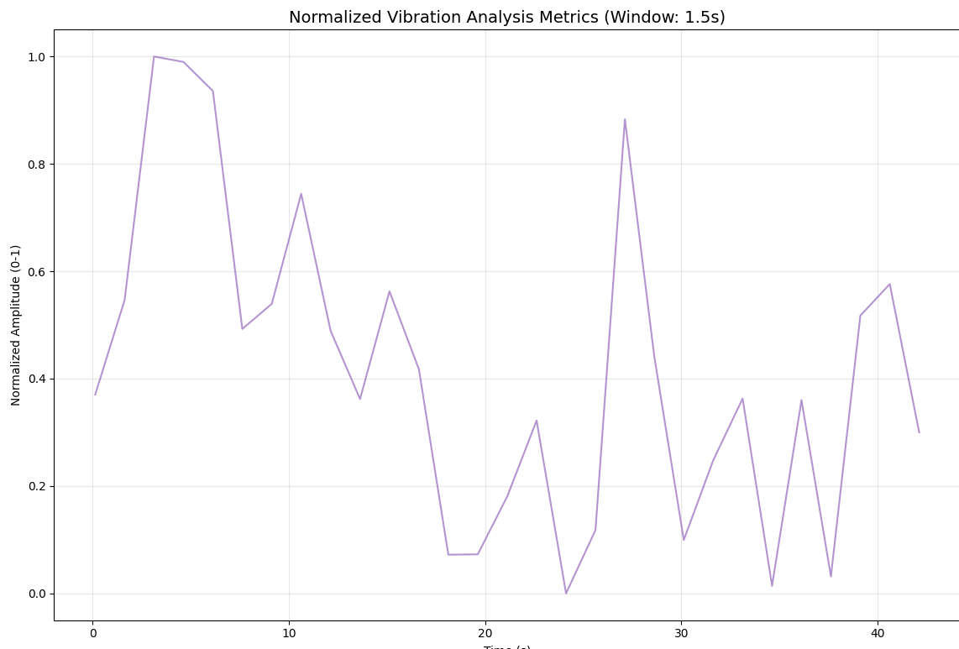

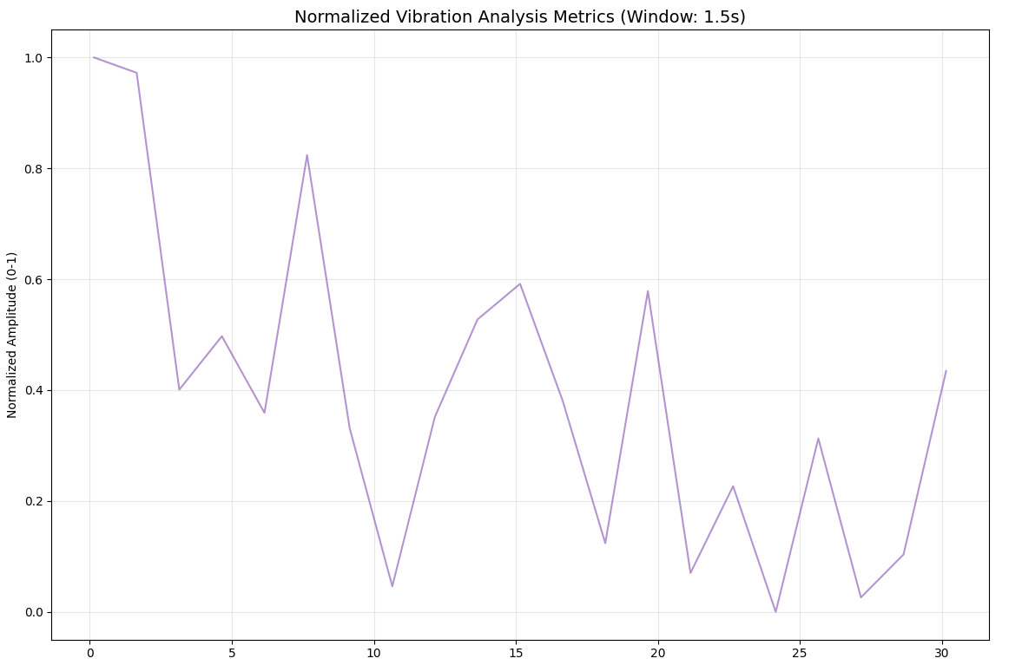

More research has to be done here to identify if really,

* Fatigue exists once the ratio reaches a specific baseline, which is defined as the inverse value of the MNF/ARV and it is the initial values of the MNF and ARV to eliminate individual differences.
* The conversion of the correlation coefficient from positive to negative is regarded as a sign of muscle fatigue.

1. Algorithm B of thesis (<https://doi.org/10.3390/s22051900>), but improved. This algorithm divides the segmented signal in a high-frequency sub-signal (HFSS) and a low-frequency sub-signal (LFSS). Then, the instantaneous mean amplitude (IMA) was calculated for the two sub-signals to ultimately obtain the fatigue index, which represents the difference between the IMA values of the LFSS and HFSS, respectively. The high-frequency components had been identified to be in the range of 80–350 Hz. The LFC lay in the range of 25–79 Hz. Then, the fast Fourier transform (FFT) was applied to these sub-signals to produce the LFSSf and HFSSf.



Plotted the fatigue index of each person. Iterations side by side for the 3 repetitions of each person towards the right. We expected and can actually see that this index gets larger the more time the muscle is being used and in many cases the index gets higher by iteration.

1. Another very promising work was done this year (<https://doi.org/10.15632/jtam-pl/177321>). This work is based on multifractal detrended moving average (MFDMA). According to the calculations that MFDMA can perform, the four multiple fractal characteristics of SOM, DOM, DFS and PSE widths of the multifractal spectra were wider during fatigue than when they were during non-fatigue.

SOM: Strength of Multifractality (range of singularity strengths (αmax−αmin) in the multifractal spectrum.)

DOM: Degree of Multifractality (range of Hurst exponents (Hmax−Hmin), which describe long-term correlations in the signal.)

DFS: Difference of Multifractal Spectrum (height difference in the multifractal spectrum (f(αmax)−f(αmin)).)

PSE: Peak Singularity Exponent (focuses on a specific point in the multifractal spectrum (α(q=−5)), representing the dominant local scaling behavior.)

The multifractal spectrum are symmetrical along the approximate axis in the non-fatigued condition, but with muscular fatigue, this symmetry tendency is greatly diminished. The SOM, DOM and PSE features have clear feature distinctions between the non-fatigue and fatigue states.

The difference between the aforementioned mean values of the properties of the myoelectric signals under the fatigue and non-fatigue scenarios was observed using the t-test method in order to further determine whether the SOM, DOM, DFS and PSE extracted by the MFDMA algorithm have statistically significant differences under such scenarios.

According to the findings, the three characteristics (SOM, DOM and PSE) that were derived from the multiple fractal spectrum using the MFDMA method were statistically significant (P-value 0.01) in determining whether or not the muscles were exhausted.

***********Still on implementation phase.*****************

# 2. Regression Modeling for Fatigue Index Creation

* **Objective**: To develop a new fatigue index by combining multiple fatigue-related metrics using regression techniques.
* **Regression Model Development**:
  + Use the identified metrics as inputs to train regression models.
  + Experiment with various predictions of how fatigue trends over time during the task (e.g., linear increase, exponential decay, or other hypothetical fatigue curves).
  + Designed the model’s output to approximate these expected fatigue trends.
* **Training and Validation**:
  + Experiment with multiple regression techniques (e.g., linear regression, polynomial regression, or machine learning models).
  + Evaluate the models based on their ability to predict trends that best align with fatigue progression.
* **Outcome**:
  + Identify the best-performing regression approach.
  + Demonstrate that the new fatigue index provides an accurate and reliable representation of fatigue progression, even in the absence of direct fatigue measurements.